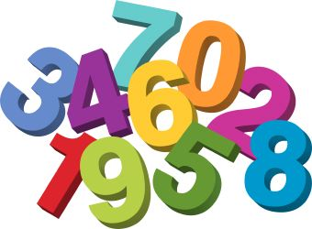
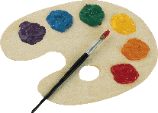
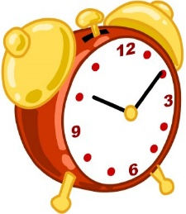
Unit 2: Lista de Vocabulario
Los Números 0-100, Los Colores, y La Hora (time)
Information is in Exploring Spanish Textbook on pg. 30 for numbers and pg. 166 for time.
Inglés | Español
zero | cero
- one
- two
- three
- four
- five
- six
- seven
- eight
- nine
- ten
- eleven
- twelve
- thirteen
- fourteen
- fifteen
- sixteen
- seventeen
- eighteen
- nineteen
- twenty
- twenty-one
- twenty-two
- twenty-three
- twenty-four
- twenty-five
- twenty-six
- twenty-seven
- twenty-eight
- twenty-nine
- thirty
- At 31 must use this format to write numbers: | Tens# + y + Ones#  31: treinta y uno  32: treinta y dos  33: treinta y tres  Etc.
- forty
- fifty
- sixty
- seventy
- eighty
- ninety
- one hundred
- +
- X
- -
- / (divided by)
- = | Son
- Time | La hora
- What time is it?
- It’s 1 o’clock.
- It’s 2 o’clock.
- It’s midnight. | Es medianoche.
- It’s noon. | Es mediodía.
- Half (30 min.) | media
- Quarter (15 min.) | cuarto*
- Minus | menos
- Y | and
- Orange
- Red
- Pink
- Gray
- Green
- Purple
- Yellow
- Brown
- Blue
- Black
- White
- Los colores | colors

